**EXPERIMENT 1: VERIFICATION OF OHM’S LAW FOR COMBINATION OF RESISTORS**

Name: Asmito Ghosh

Registration Number: IACS02721

Group: A2

Laboratory Partner: Ankur Saha

Date: 12/08/2024

OBJECTIVE:

* To investigate all the variables involved in a mathematical relationship of Ohm's Law.
* To assemble resistors in series and in parallel circuits.
* To state the effect of series and parallel connections of resistors to the equivalent resistance.

THEORY:

* Ohm’s Law states that the resistance (R) of a circuit is directly proportional to the voltage (V) inversely proportional to the current (I) across the circuit:

$$R=\frac{V}{I}$$

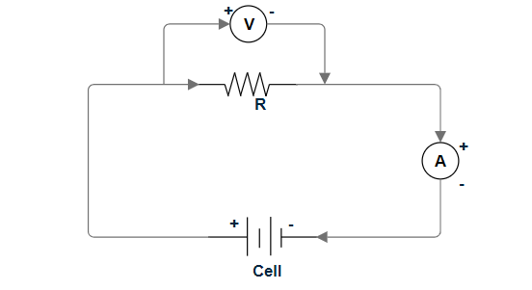

* For n resistors arranged in series, the equivalent resistance is:

$$R_{eq}= \sum_{i=1}^{n}{R_{i}}$$

The circuit for 2 such resistors in series would be:  
 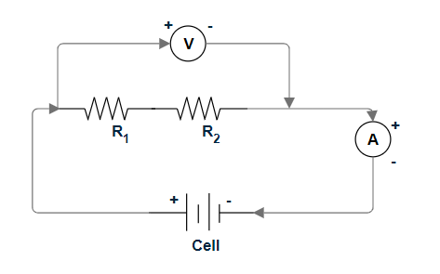

* For n resistors arranged in parallel, the equivalent resistance is:

$$R_{eq}= \frac{1}{\left(\sum_{i=1}^{n}{\frac{1}{R_{i}}}\right)}$$

The circuit for two such resistors in parallel would be:

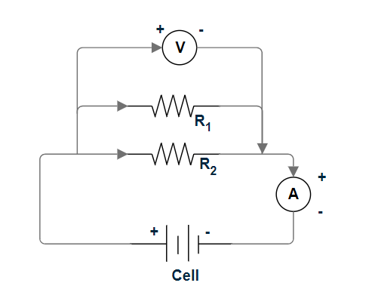

APPARATUS REQUIRED:

* Three resistors of different resistances
* Battery
* Voltmeter
* Milliammeter
* Rheostat
* Connecting Wires
* Switch

PROCEDURE:

Part A: Ohm’s Law:

* An individual resistor (R1) is chosen from the three resistors and the apparatus is set up as shown above.
* The circuit was closed. The voltage across the resistor was changed using the rheostat and change in current was observed.
* The voltmeter and milliammeter readings were recorded, and the relation between them was charted in a V-I graph.
* Resistor R1 was replaced with resistor R2 and then resistor R3 and the steps were repeated.

Part B: Equivalent Resistance:

* The apparatus was set up as previously shown using resistor R1 and R2. The circuit was closed.
* The voltage across the resistor was changed using the rheostat and corresponding change in current was observed.
* The voltmeter and milliammeter readings for the combined resistance were recorded, and the relation between them was charted in a V-I graph.
* The steps were repeated for R1 and R3, and then for R2 and R3.
* Now, the apparatus for parallel resistance was set up using R1 and R2.
* The voltmeter and milliammeter readings are recorded and charted in a V-I graph.
* The steps are repeated for parallel combination of R1 and R3, R2 and R3.

RESULTS:

Resistances of the individual resistors:

|  |  |  |  |  |
| --- | --- | --- | --- | --- |
|  | Voltage | Current(mA)  R1 | Current(mA)  R2 | Current(mA)  R3 |
| Range | 0–15V | 0-200 mA | 0-200 mA | 0 – 200mA |
| 1 | 0.00 | 0.0 | 0.0 | 0.0 |
| 2 | 0.50 | 10.7 | 4.7 | 2.4 |
| 3 | 1.00 | 21.9 | 10.1 | 4.4 |
| 4 | 1.50 | 32.9 | 15.3 | 6.9 |
| 5 | 2.00 | 43.2 | 20.8 | 9.3 |
| 6 | 2.50 | 54.2 | 25.5 | 11.7 |
| 7 | 3.00 | 65.7 | 29.8 | 13.7 |
| 8 | 3.50 | 76.1 | 36.2 | 16.4 |
| 9 | 4.00 | 87.5 | 40.8 | 18.5 |
| 10 | 4.50 | 97.8 | 46.0 | 20.9 |
| 11 | 5.00 | 109.9 | 50.7 | 23.0 |
| 12 | 5.50 | 120.5 | 56.1 | 25.6 |
| 13 | 6.00 | 132.4 | 62.0 | 27.8 |
| 14 | 6.50 | 141.7 | 66.5 | 30.1 |
| 15 | 7.00 | 153.4 | 72.4 | 32.8 |
| 16 | 7.50 | 165.0 | 77.1 | 35.0 |
| 17 | 8.00 | 177.6 | 82.8 | 37.4 |
| 18 | 8.50 | 189.2 | 87.6 | 39.6 |
| 19 | 9.00 | 199.7 | 93.1 | 42.1 |

Resistances in Series:

|  |  |  |  |  |
| --- | --- | --- | --- | --- |
|  | Voltage | Current(mA) R1+R2 | Current(mA) R1+R3 | Current(mA)  R2+R3 |
| Range: | 0–15V | 0-200 mA | 0-200 mA | 0 – 200mA |
| 1 | 0.00 | 0.0 | 0.0 | 0.0 |
| 2 | 0.50 | 3.6 | 1.9 | 1.6 |
| 3 | 1.00 | 7.3 | 3.8 | 3.2 |
| 4 | 1.50 | 10.7 | 5.7 | 4.8 |
| 5 | 2.00 | 14.1 | 7.5 | 6.5 |
| 6 | 2.50 | 17.7 | 9.7 | 7.8 |
| 7 | 3.00 | 20.6 | 11.6 | 9.5 |
| 8 | 3.50 | 24.2 | 13.4 | 11.0 |
| 9 | 4.00 | 27.8 | 15.3 | 12.6 |
| 10 | 4.50 | 31.1 | 17.2 | 14.3 |
| 11 | 5.00 | 34.6 | 18.8 | 15.7 |
| 12 | 5.50 | 38.5 | 20.9 | 17.3 |
| 13 | 6.00 | 41.8 | 22.8 | 19.2 |
| 14 | 6.50 | 45.3 | 24.8 | 20.7 |
| 15 | 7.00 | 49.0 | 26.7 | 22.3 |
| 16 | 7.50 | 52.2 | 28.6 | 23.8 |
| 17 | 8.00 | 55.4 | 30.5 | 25.6 |
| 18 | 8.50 | 59.6 | 32.4 | 27.2 |
| 19 | 9.00 | 63.1 | 34.5 | 28.8 |

Resistances in Parallel:

|  |  |  |  |  |
| --- | --- | --- | --- | --- |
|  | Voltage | Current(mA) R1||R2 | Current(mA) R1||R3 | Current(mA)  R2||R3 |
| Range: | 0–15V | 0-200 mA | 0-200 mA | 0 – 200mA |
| 1 | 0.00 | 0.0 | 0.0 | 0.0 |
| 2 | 0.50 | 15.4 | 12.5 | 6.9 |
| 3 | 1.00 | 33.4 | 27.5 | 15.7 |
| 4 | 1.50 | 48.4 | 39.1 | 21.8 |
| 5 | 2.00 | 62.9 | 52.3 | 30.2 |
| 6 | 2.50 | 78.5 | 65.1 | 37.0 |
| 7 | 3.00 | 96.0 | 78.4 | 44.3 |
| 8 | 3.50 | 110.9 | 92.1 | 51.4 |
| 9 | 4.00 | 128.8 | 106.4 | 60.3 |
| 10 | 4.50 | 143.4 | 118.7 | 66.3 |
| 11 | 5.00 | 161.1 | 133.2 | 73.7 |
| 12 | 5.50 | 177.8 | 146.8 | 81.4 |
| 13 | 6.00 | 192.3 | 158.4 | 90.1 |

GRAPHS AND CALCULATIONS:

For Individual Resistances:

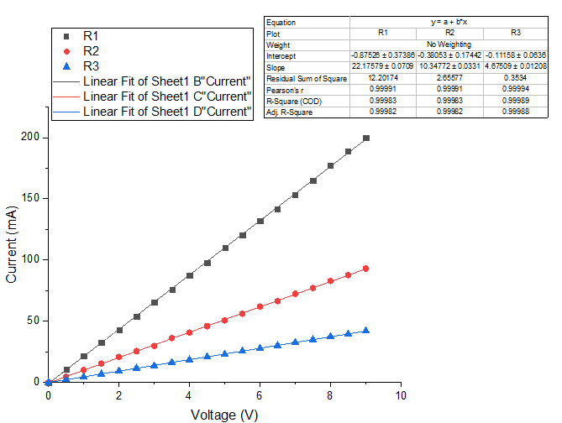

From the graph, we find:

Slope for R1 = 22.176  
⇒ R1 = 45.09 Ω (approx.)

Slope for R2 = 10.348  
⇒ R1 = 96.64 Ω (approx.)

Slope for R3 = 4.675  
⇒ R3 = 213.90 Ω (approx.)

For resistances in series:

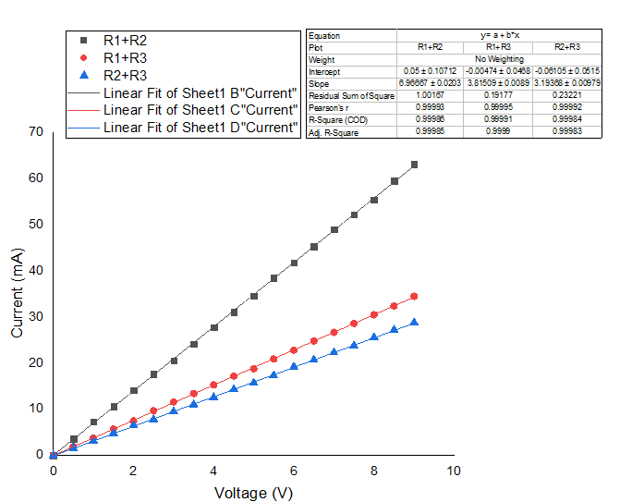

From the graph, we find:

Slope for R1+R2 = 6.97  
⇒ Equivalent resistance for series connection of R1, R2 = 143.47

Slope for R1+R3 =3.82  
⇒ Equivalent resistance for series connection of R1, R3= 261.78

Slope for R2+R3 =3.19  
⇒ Equivalent resistance for series connection of R2, R3= 313.48

For resistances in parallel:

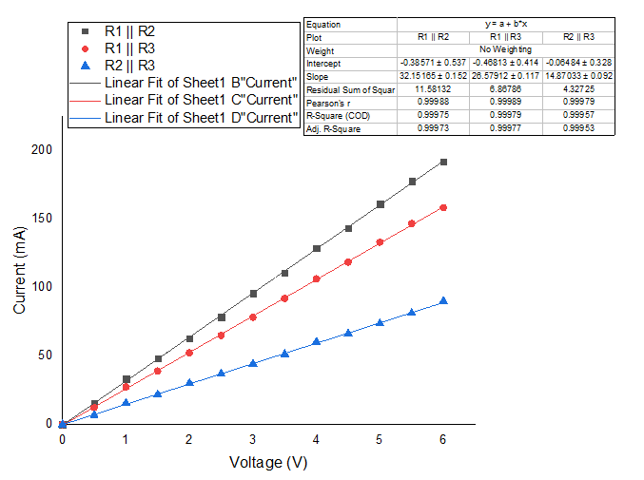

From the graph, we find:

Slope for R1||R2 = 32.15  
⇒ Equivalent resistance for parallel connection of R1, R2 = 31.10

Slope for R1||R3 = 26.58  
⇒ Equivalent resistance for series connection of R1, R3= 37.62

Slope for R2||R3 =14.87  
⇒ Equivalent resistance for series connection of R2, R3= 67.25

ERROR ANALYSIS:

According to Ohm’s Law,

⇒

⇒

⇒ max max max

To calculate approximate instrumental error, we are taking case where V = 6.00V.

1. A) For R1, R2 in series, I = 41.8 mA

Maximum Percentage Error = max = 0.41%

Maximum Error = 0.41% *(143.47) Ω = 0.59 Ω

B) For R1, R3 in series, I = 22.8 mA

Maximum Percentage Error = max = 0.61%

Maximum Error = 0.61% *(261.78) Ω = 1.60 Ω

C) For R2, R3 in series, I = 19.2 mA

Maximum Percentage Error = max = 0.69%

Maximum Error =0.69% *(313.48) Ω = 2.09 Ω

1. A) For R1, R2 in parallel, I = 192.3 mA

Maximum Percentage Error = max = 0.22%

Maximum Error =0.22% *(32.15) Ω = 0.07 Ω

B) For R1, R3 in parallel, I = 158.4 mA

Maximum Percentage Error = max = 0.23%

Maximum Error =0.23% *(37.62) Ω = 0.09 Ω

C) For R2, R3 in parallel, I = 90.1 mA

Maximum Percentage Error = max = 0.28%

Maximum Error = 0.28% *(67.25) Ω = 0.18 Ω

Deviation from theoretical values of equivalent resistances, as per Ohm’s Law:

1) Equivalent resistances in Series:

A) Theoretical Value of equivalent resistances of R1, R2 = 141.73 Ω  
 Experimental value of equivalent resistance of R1, R2 = 143.47 Ω  
 Deviation of Experimental Value = 1.23%

B) Theoretical Value of equivalent resistances of R1, R3 = 258.99 Ω  
 Experimental value of equivalent resistance of R1, R3 = 261.78 Ω  
 Deviation of Experimental Value = 1.08%

C) Theoretical Value of equivalent resistances of R2, R3 = 310.54 Ω  
 Experimental value of equivalent resistance of R2, R3 = 313.48 Ω  
 Deviation of Experimental Value = 0.95%

2) Equivalent resistances in Parallel:

A) Theoretical Value of equivalent resistances of R1, R2 = 30.75 Ω  
 Experimental value of equivalent resistance of R1, R2 = 31.10 Ω  
 Deviation of Experimental Value = 1.14%

B) Theoretical Value of equivalent resistances of R1, R3 = 37.24 Ω  
 Experimental value of equivalent resistance of R1, R3 = 37.62 Ω  
 Deviation of Experimental Value = 1.02%

C) Theoretical Value of equivalent resistances of R2, R3 = 66.57 Ω  
 Experimental value of equivalent resistance of R2, R3 = 67.35 Ω  
 Deviation of Experimental Value = 1.17%

REMARKS:   
Thus, we set up a circuit of resistors in series and in parallel, hence comparing between the results from our experiment with the theoretical results as per Ohm’s Law.

SNAPSHOT OF LABORATORYNOTEBOOK:

